* Full name: Iván Kaleb Ramírez Torres
* NAO ID: 3357
* Date: September 11th, 2025
* Name of the pathway in which you are enrolled: Bécalos Techno Ready
* Title of the Challenge: **Develop – Screenshot report**

## Table of Contents

|  |  |
| --- | --- |
| Screenshot | Content |
| 1 | Creation of branch "A" from "Master" |
| 2 | Creation of docs.txt in branch "A" |
| 3 & 4 | PR created for branch "A" |
| 5 | Creation of branch "B" from "Master” |
| 6 | Creation of a different docs.txt in branch "B" |
| 7 | PR created for branch "B" |
| 8 | Conflict resolution process |
| 9 & 10 | Git command used to revert changes |
| 11 | Approved PRs and merged branches |

## Screenshots

### Creation of branch "A" from "Master"

It was confirmed being in the correct branch “main” from local repository with command “git branch” and then, from main branch it was created the new branch named “A” and then switched to there with “git checkout” command.

1. Creation of docs.txt in branch "A"

Once in “A” branch, file *docs.txt* was created with “New-Item” command and confirmed with “ls” command. Subsecquently, with “nano docs.txt” it was modified in order to create a conflict ahead.

3 & 4. PR created for branch "A"

In order to create a Pull Request (PR) the git status was checked and then the document docs.txt was added to staging area and commited for then being pushed to GitHub repository with commands showed in the screenshot (SS).

On GitHub repository the PR was created but not accepted and merged yet.

5. Creation of branch "B" from "Master"

Following the previous steps for branch “A”, branch "B” was created with same commands from “main”.

### 6. Creation of a different docs.txt in branch "B"

### Texto El contenido generado por IA puede ser incorrecto.File docs.txt was created same as in branch “A” and confirmed status and pushed to GitHub repository.

### 7. PR created for branch “B”

SS showing the PR created but not merged from GitHub repository.

### 8. Conflict resolution process

After merging one of the PRs, in this case, the branch “A” one, it was noticed a version’s conflict in banch B’s PR that was needed to be solved.

In terminal, once changes in branch “A” were merged, main branch was actualized with “git pull” command for having the merged changes in local repository. After this, switching to branch “B” it was tried to merge the main into B and the conflict was marked graphically by showing the content in file comparing lines modified in “A” with “B” in same file. With command “git reset”, conflict disappeared.  
This means that last commit in branch B returned to working area from staging area (doc.txt modified), but the changes were conserved into de file already modified from A and merged in main. This is quite convenient since we can conserve both changes since maybe we need both.  
Changes were conserved in just one file and new PR was made and finally merged.

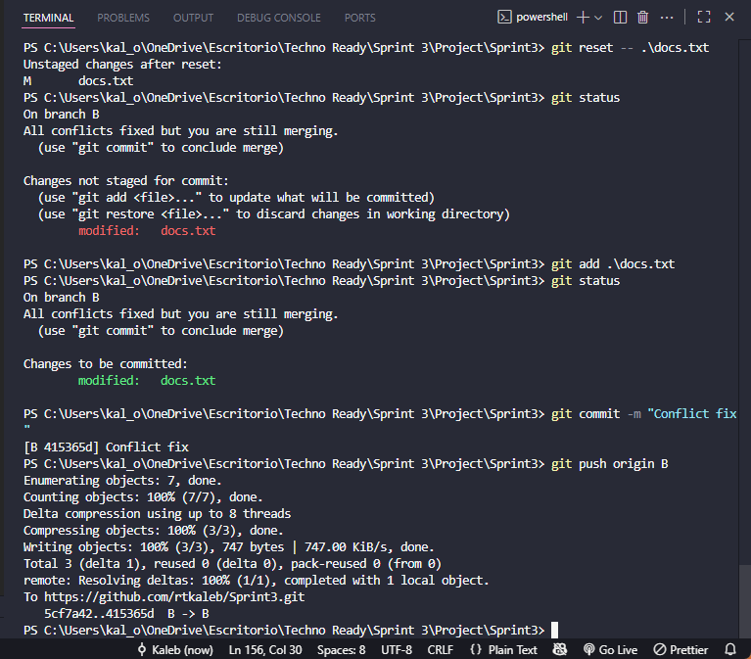

11. Approved PRs and merged branches

Finally, new PR was accepted, free of conflicts and then merged.